Read Daniel 2:31-45

1. What was impactful to you from the sermon?

2. On the next page you will find a representation of the image Nebuchadnezzar saw. Try to fill in the kingdoms corresponding to each metal if you can. Do you see any helpful evidence in Daniel? *SPOILER ALERT* On the 3rd page find a short commentary note to help you after doing your own work.

3. Write down what you learn about the stone in v. 34-35 and 44-45 what do you think it represents? How are you encouraged about the stone becoming a great mountain?

4. In verse 37-43 we see kingdoms decreed to rise and fall. How can you have a more stable faith while knowing the fate of the kingdoms of this world?

5. What do you notice about the kingdom that God will set up? How can you already find stability by faith in the kingdom Jesus founded at His first coming? Are these two different kingdoms or the same one? (For help see Heb. 2:5-18)

6. How do Christians get confused or even deceived about the nature of the kingdom of Christ today and how do these lead to misguided ministry approaches?

7. In verse 45 Daniel declares the certainty of this interpretation. How could you yield your heart in greater measure to the rule of Christ as you wait for His return?

Prayer Focus: Let's pray for our hearts to be continually more yielded to the rule of Jesus Christ today.

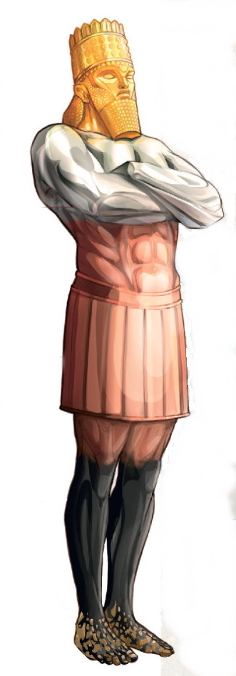

GOLD

SILVER

BRONZE

IRON

IRON/CLAY

Daniel 2:43–44 The Aramaic description of intermarriage as mixing “by the seed of men” (see ESV footnote) recalls the prohibition on sowing mixed seed in a field (Lev. 19:19). At that time, God will establish a kingdom that shall never be destroyed, his final kingdom, which will ultimately destroy all other kingdoms. Though it starts small, it will grow to fill the earth and, unlike the earthly kingdoms, it will endure forever (cf. “stone,” “great mountain,” Dan. 2:34–35). It is striking that God gave this dream to Nebuchadnezzar in the seventh century b.c. (about 602; see note on v. 1), for in this dream and in the subsequent visions linked to it in ch. 7 and 8, God predicts in accurate detail the future kingdoms that would arise to dominate world history in the sixth, fourth, and first centuries b.c. Traditional commentators through the history of the church have almost universally identified the four kingdoms as Babylon, Medo-Persia (established by Cyrus in 539 b.c.; specifically named in 8:20), Greece (under Alexander the Great, about 331; specifically named in 8:21), and Rome (the Roman Empire began its rule over Palestine in 63). Those scholars, however, who assume that Daniel’s detailed visions cannot be predictive prophecies, but had to have been written after the events they claim to “predict,” hold that Daniel was written not in the sixth century b.c. but in the second century, in the Maccabean period. Under this scheme the fourth kingdom cannot be the Roman Empire, which did not yet exist at that time. So they propose various other identifications for the kingdoms, such as (1) Babylon, (2) Media, (3) Persia, and (4) Greece; however, Media was never an independent world power after Babylon fell to Cyrus in 539 b.c. (it was also ruled by Cyrus). Another point being made in the dream is that each earthly kingdom has its own glory but also its own end: both have been assigned to it by God. The progression of world history is typically not upward to glory and unity but rather downward to dishonor and disunity. Thus the statue progresses from gold, to silver, to bronze, to iron, and from one head, to a chest and arms, to a belly and thighs, to feet and toes of composite iron and clay. (This list of metals shows a progressive decrease in the value and splendor of the materials but an increase in toughness and endurance. Some commentators understand this to indicate a general decline in the moral quality of the governments and an increase in the amount of time they lasted. See chart below. In contrast, God’s kingdom grows from humble beginnings to ultimate, united glory as a single kingdom that fills the whole earth forever. The stone that will break in pieces all these other four kingdoms is most likely Christ (see Luke 20:18). He is the mystery of the ages, the one in whom God plans to unite all things in his glorious kingdom (Eph. 1:9–10).

Crossway Bibles, The ESV Study Bible (Wheaton, IL: Crossway Bibles, 2008).
Exported from Logos Bible Software, 16:18 May 27, 2022

