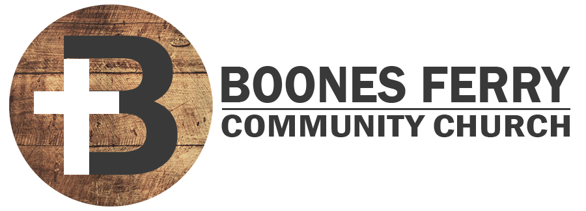
Read Genesis 9:18 – 10:32

1. How did Sunday's sermon impact you or what did you learn in Word Like Fire II?

2. Challenge. What does God's word say and not say about drinking? How do Christians and churches sometimes get this doctrine wrong?

3. Why is Ham's response so wrong hearted? How might you pray for prophetic blessing for a child's or christian friend's heart attitude.

4. What does Noah's prophetic curse reveal about Ham's future legacy through Canaan? What does Noah's blessing of Shem and Japheth reveal about their future relationship to God? What unmerited blessings have you received recently?

5. Consult the table of nations to see where the different tribal heads ended up geographically. What kinds of world view shaping conclusions about the origins of nations can be drawn from this biblical genealogy?

6. When viewing a genealogy that spans generations, we are able to see how impactful the character of the original patriarch is. What legacy do you want to leave, and what future impact might that have on a generational level?

7. Reflection. Consider what heart attitudes in your life would have a blessed or cursed impact on your future or influence on another's future. Ask God to help you erase the attitudes that are sinful.

Prayer Focus: Let's pray that we would surrender our heart attitudes to the Spirit and let go of those that are sinful.

TABLE OF NATIONS

