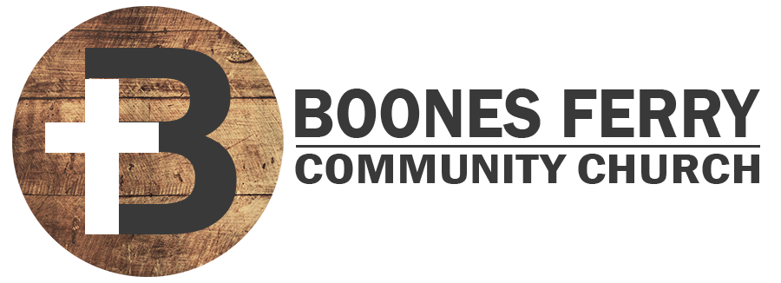
Read Genesis 6:9-7:24

1. How did Sunday's sermon impact you or what did you learn in Word Like Fire?

2. Challenge. What does it mean for Noah to be righteous and blameless? That does it mean for you to be righteous and blameless?

3. What would you say to someone who was struggling with God's judgment to flood the earth? What has helped you trust Him more in this area of faith?

4. What details about the preparation of the arc, the gathering of the animals and the causes and effects of the flood stand out or seem significant to you and why?

5. Describe what you might have felt if you had been one of the 8 people saved in all the world while the flood waters were rising?

6. Read verses 15-16 along with 1 Peter 3:18-21. How is Noah's arc a sign of the cross and resurrection of Jesus Christ and therefore baptism? How has God shut you into His plan for salvation from His future wrathful judgment?

7. Reflection. God called Noah to participate in His plan for salvation. How has God also called you to do the same today?

Prayer Focus: Let's pray that we would more deeply appreciate the salvation we have in Jesus Christ our true ark.

