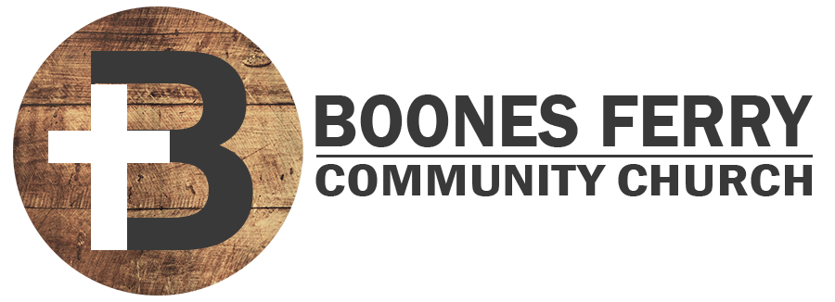
Read Genesis 17:1-14

1. How did Sunday's sermon impact you or what did you learn in Word Like Fire?

2. Read vs 1-2. Is the covenant of circumcision conditional or unconditional? Please explain your answer.

3. When God changed Abram's name to Abraham, how may that have affected him? How has understanding your own identity in Christ shaped your life?

4. How do you see God's gospel plan of including other nations as His people already inherent in the covenant of circumcision?

5. Challenge. Read Deut. 10:16, 30:6, Ezek. 36:26-27, 1 Cor. 7:18-19. Why can God call the covenant of circumcision everlasting, if Christians don't have to be circumcised anymore?

6. Read Rom. 4:11-12. Why is it such good news that the act of being circumcised is the seal of righteousness by faith rather than the cause? How might you still be leaning on your own efforts to be right with God?

7. Youth Question. God calls Abram to walk before Him and be blameless. What do you think that means? Do you think it means Abram has to be perfect? Please explain.

Prayer Focus: Let's pray that we would remember to live according to the circumcised hearts God has given us.

DC leaders can ask this question any time for discussion that intends to involve our younger members. You might ask them in advance if they want to answer it. If they do not, this question can be for parents to discuss with them at home.

