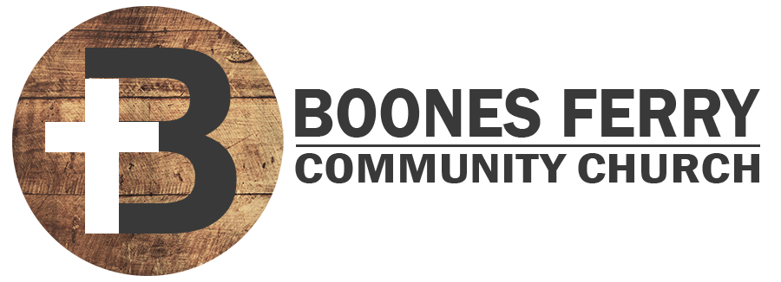
Read Genesis 8:20-9:17

1. How did Sunday's sermon impact you or what did you learn in Word Like Fire?

2. What precipitated God promising to never curse the ground or destroy all life on earth again? What does this teach you about atonement in relationship to God?

3. Read verse 8:22 and Matt. 24:35. What do you think about the message of doomsday prophets who prophecy the end of the world through climate change? How should knowing only the word, but not this world, will last impact your priorities?

4. What provisions does God promise for humanity in 9:1-3? List some of the things that you are thankful for in your own life that are in these categories.

5. What does God say about the blood of animals and men? How does the judgement of those who shed the blood of man not only point to God's justice but even the cross?

6. How does God's covenant and sign establish a stable and reliable environment for obedience to being fruitful and multiplying, even spiritually through discipleship?

7. Reflection. What does God remember when He sees a rainbow? What has humanity made that image into now? How does this effect your view of human nature?

Prayer Focus: Let's pray that we would remember that God's covenants are always exclusively a sign of His mercy and never our own goodness.

