Read Daniel 8:1-27 (See resources on the next 2 pages)

1. What are you learning about the end times and how is it challenging you to grow?

2. What does Gabriel reveal to Daniel about the identity of the ram and the goat? How would this have encouraged the Jews during the reign of the Medo-Persians? How should it encourage us considering the wars and rumors of wars we hear about?

3. Read the paragraph below and scan the map. How was the prophecy of verse 8 fulfilled? Considering that none of these men were even born yet, how does prophecy such as this bless God's people through the ages?

4. What does Gabriel say twice, once in 17 and again in 19, that the vision are about? Is there any portion of verses 9-14 that seems to point to something future to our time?

5. Challenge. Using bible helps, what are some of the interpretations pertaining to the meaning of 9-14? Which of these interpretations seem most convincing to you and how does it urge you to grow in faithfulness?

6. In verse 11 and 25 we see the phrases "Prince of the host" and "Prince of princes". Who do you think he is and how does the little horn's defeat strengthen Christians in the face of future persecution?

7. What practical steps can you take to increase your trust in God to defeat spiritual opposition in your life?

Prayer Focus: Let's pray that Christ's future victory increases our present trust during times of trial.

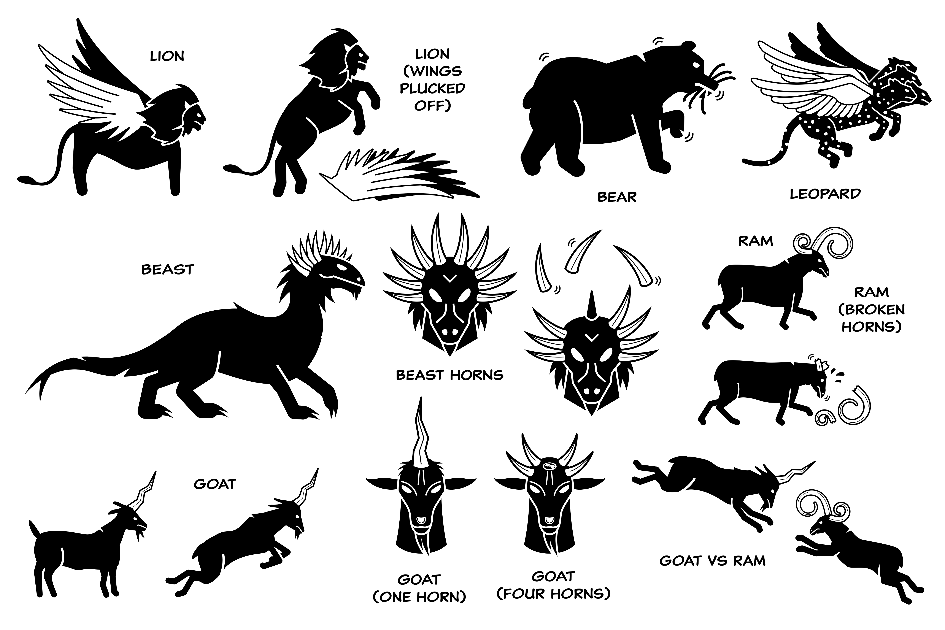
Practically all commentators, however, recognize the four horns as symbolic of the four kingdoms of the Diadochi which emerged as follows: (1) Cassander assumed rule over Macedonia and Greece; (2) Lysimacus took control of Thrace, Bithynia, and most of Asia Minor; (3) Seleucus took Syria and the lands to the east including Babylonia; (4) Ptolemy established rule over Egypt and possibly Palestine and Arabia Petraea. A fifth contender for political power, Antigonus, was soon defeated. Thus, with remarkable accuracy, Daniel in his prophetic vision predicts that the empire of Alexander was divided into four divisions, not three or less or five or more.

John F. Walvoord, Daniel: The Key To Prophetic Revelation

