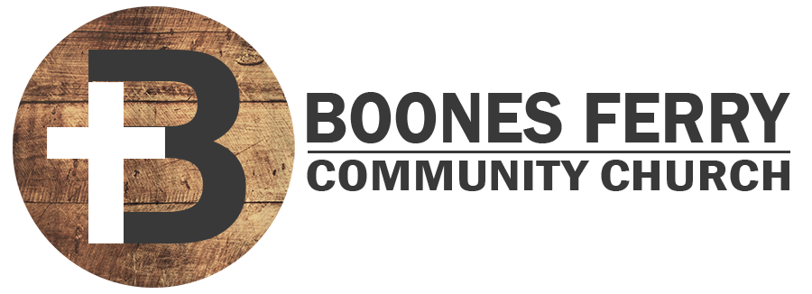
Read Genesis 15:1-21

1. How did Sunday's sermon impact you or what did you learn in Word Like Fire?

2. Why did God tell Abram not to fear, and what first fear did Abram express to God after that? What fears about your future or the future of your family might you need to express to God?

3. Read Gen. 15:4-6 What was God's answer? How is Abram's response to just believe God a model to you even in circumstances where it seems like it’s too late for God to keep His promises?

4. Read Gal. 3:5-9. What does it actually mean to be counted righteous by faith? Why is it such good news that our works are not included in us being counted as righteous by God?

5. Read Jeremiah 34:18-19. When God answers Abram's second fear of not knowing that he will really possess the land, God answers by making a convenient with him. What does it mean that only God participated in the traveling through the animals that were cut in two?

6. Challenge. How is the cross of Jesus Christ the ultimate fulfillment of God having to keep the covenant that would bring us into the final promise land? (See Heb. 11:8-10 and 12:1-2)

7. Reflection. In what area of your life are there fears that tend to undermine your faith that God is faithful to keep His promises and work all things towards good for you?

Prayer Focus: Let's pray that we would believe God's promises of redemption even when it seems like it's too late.

