Read Daniel 11:1-45 (IMPORTANT The historical notes on the next page are supplied to be helpful in understanding this passage but are not required to be read in full to answer these questions)

1. What did you take away from the sermon or Word Like Fire this week?

2. Historically who are some of the king(s) of the south and the north and what kingdoms do they rule over? Can you name one or two ways the prophecy of their battles are fulfilled with incredible accuracy?

3. Geopolitical conflict, wars and rumors of wars are foretold as end time signs by Jesus. How does political upheaval affect you and how can your faith help stabilize your outlook?

4. Read Daniel 11:29-33 and Matt. 24:15-25. Since Jesus refers to the abomination that causes desolation, how does this influence your understanding of the timeline of the events and person discussed here.

5. Since the deception of the Antichrist will be so powerful we must be prepared to be uncompromisingly faithful. What has God given us to strengthen our faith and how might you take greater advantage of these things?

6. Read 11:36-37. What is the endgame of the Antichrist? In what ways do you see our culture already bowing the knee to his spirit and how is this a warning for us also?

7. How could the spirit of the antichrist use idols to gain traction in tempting people to support his agenda? What kinds of idols might you need to give up in order to be less vulnerable to his work?

Prayer Focus: Let's pray that we would grow in uncompromising faithfulness.

11:2–45 A Detailed Vision of Future Earthly Conflicts among Nations. This passage gives a selective yet detailed overview of the flow of history from the time of Daniel in the late sixth century b.c. until the end of the world, the final climactic conflict and victory of God. Some scholars regard this as a “prophecy after the fact” that was actually written later than the events in the mid-second century b.c. because of the detail and accuracy of its predictions, but Isa. 44:6–7 asserts the Lord’s ability and purpose to declare ahead of time what would happen in order to demonstrate his power and sovereignty. (See Introduction: Date.) Such an assurance of God’s sovereign control of history would have been profoundly relevant for Daniel’s day. Judah was about to be restored from exile (see note on Dan. 11:1), and yet it was not really free. It would be subject to the Persians, and then to Alexander’s Greeks; after that it would be caught in the middle between powerful heirs of Alexander’s empire, the Seleucids and the Ptolemies (see map). Pious Jews would readily fall into bewilderment: how do these circumstances display God’s concern for his people, and how will God ever use his now-insignificant people to bring blessing to the whole world? The vision is therefore reassurance for the faithful.
11:2 Three more kings would arise in Persia after Cyrus (Cambyses [530–522 b.c.], Smerdis [522], and Darius I Hystaspes [522–486]), and then a fourth, who would be richer and more powerful than the others and would enter into conflict with Greece. This fourth king was Xerxes I (486–464 b.c.), who invaded Greece, only to be defeated at the Battle of Salamis (480).
11:2 Tumults and wars on earth continue until the end (Matt. 24:6–7; Rev. 6:2–4) and remind us of spiritual war, part of which is invisible (Rev. 12:7–9). In the midst of tumult, Christ alone provides true peace (John 16:33; cf. Phil. 4:6–7; 1 Thess. 3:4).
11:3 Several other lesser Persian kings are then passed over without mention as the prophecy moves on to the next significant ruler, the mighty king who would bring down the Persian Empire and rule a vast realm (a great dominion), Alexander the Great (336–323 b.c.).
11:4 as soon as he has arisen, his kingdom shall be broken and divided toward the four winds of heaven. Alexander the Great died in 323 b.c., shortly after establishing an enormous empire that was eventually divided among his four generals—none of whom were his posterity, as the prophecy says.
11:5–20 This section contains prophecies concerning the kings of Egypt and Syria. Two of the four kingdoms that came from Alexander’s empire were the kingdom of the Ptolemies (based in Egypt) and the kingdom of the Seleucids, (based in Syria and Babylonia). This chapter deals only with these two kingdoms since they will have the most influence on Israel. Many of the specific predictions of this chapter were fulfilled in striking detail.
11:5 Ptolemy I Soter (323–285 b.c., king of the south) was a very capable general under Alexander who became ruler of Egypt. About the same time, Seleucus I Nicator (king of the north) started out as a lesser general under Alexander and was given Babylon to rule, but one of the other generals, Antigonus I Monophthalmus, took over Babylon and caused Seleucus to flee (c. 316 b.c.). He fled south to Ptolemy I Soter in Egypt to serve under him. Thus for a short time he became one of his princes. Then Antigonus was defeated at Gaza in 312 b.c., and Seleucus returned to Babylon to retake his former authority. He increased significantly in power and took over the areas of Babylon, Syria, and Media, so that he was stronger than Ptolemy I Soter.
11:6 There was constant conflict between the Ptolemaic (Egyptian) and Seleucid (Syrian) kingdoms, but around 250 b.c. Ptolemy II Philadelphus (285–246, “the king of the south”) attempted to make peace with Antiochus II Theos (261–246, “the king of the north”) by sending his daughter Berenice to marry him, as Daniel had predicted: the daughter of the king of the south shall come to the king of the north to make an agreement. Antiochus II then planned to divorce his first wife, Laodice, and disinherit her sons so that he could marry Berenice and have a child who would then rule over the Seleucid kingdom. But Laodice had Antiochus II and Berenice poisoned, fulfilling the words she shall not retain the strength of her arm and he and his arm shall not endure. In the same year, Berenice’s father (he who fathered her) died in Egypt.
The Empires of Daniel’s Visions: The Ptolemies and the Seleucids (Early)
c. 323–198 b.c.
The two most powerful successors to Alexander, Ptolemy and Seleucus, continued to expand their domains into territory claimed by other generals of Alexander, and they repeatedly clashed with each other over land along the eastern coast of the Mediterranean Sea, including the land later called Palestine.
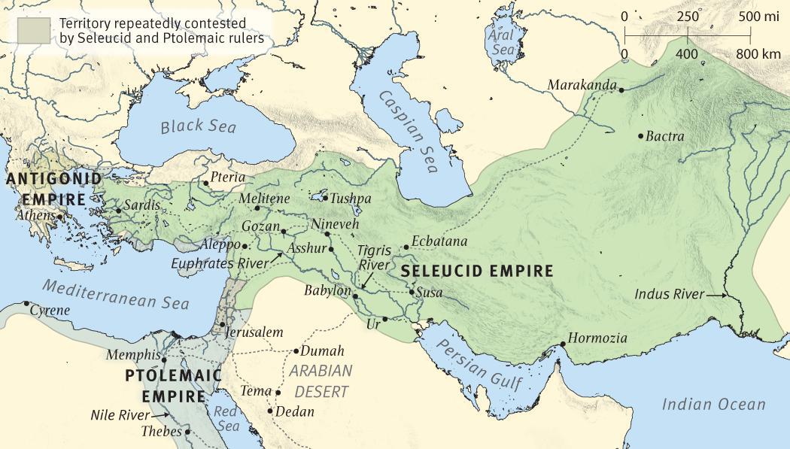
The Empires of Daniel’s Visions: The Ptolemies and the Seleucids (Late)
c. 198–133 b.c.
By the second century b.c., the Seleucid Empire was losing its grip on much of its territory, and the Roman Empire was rapidly expanding throughout the Mediterranean world. In an attempt to unite his empire and shore up his defenses against these pressures, Antiochus IV Epiphanes imposed a strict policy of Hellenization over his domain, which now included the land of Israel. His policy proved too abhorrent for many Jews, including the Maccabean (also called Hasmonean) family, and in 167 b.c. they led a revolt that established a new, independent kingdom of Israel.
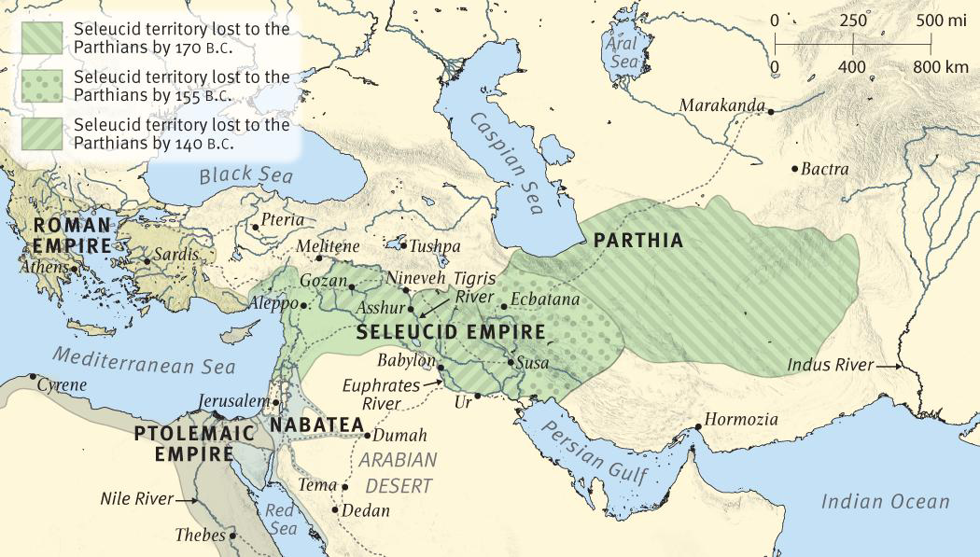
Rulers of Syria, Judea, and Egypt after Alexander the Great
The Ptolemaic Dynasty (323–30 b.c.): The name “Ptolemaic” is derived from the name of Ptolemy I Soter (367/66–283 b.c.), one of Alexander the Great’s three main succeeding generals, and was borne by all subsequent rulers of the line of Greek-speaking kings who ruled Egypt after the death of Alexander the Great (323) until the country’s annexation by Rome (30).
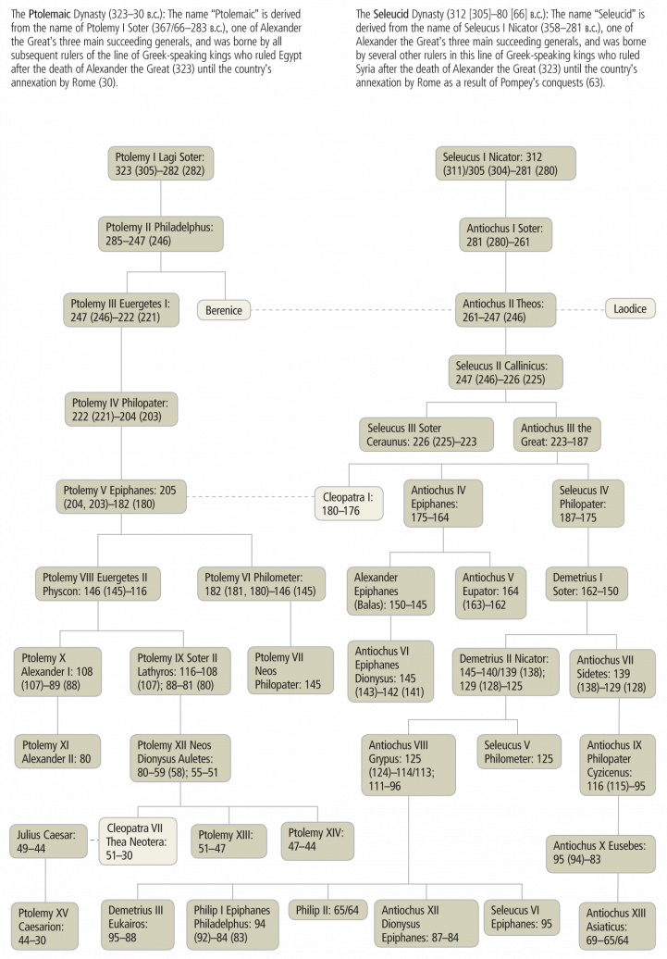
Rulers Foretold in Daniel 11
In the absence of legitimate heirs following the death of Alexander the Great in 323 b.c. (cf. 1 Macc. 1:5–9), four of his generals divided the conquered territory of his empire into fourths (which then included most of the known world throughout Europe and Asia Minor; see notes on Dan. 7:6; 8:8; 8:20–22; 11:4). By 277 b.c., three Hellenistic kingdoms had stabilized out of the four divisions: (1) the Antigonid dynasty in Macedonia (issuing from Alexander’s general Antigonus I Monophthalmus, 382–301 b.c., and beginning with his son Demetrius I Poliorcetes in 294/293); (2) the Ptolemaic dynasty in Egypt (issuing from Alexander’s general Ptolemy I Soter, 367–283 b.c.); and (3) the Seleucid dynasty in Syria (issuing from Alexander’s general Seleucus I Nicator, c. 358–281 b.c.), which included much of Asia Minor from 312 to 64 (see Dan. 11:4–35 and notes there). Though Judea came under control of the Seleucids in 198 b.c., it was initially under Ptolemaic (Egyptian) rule. Each dynasty continued until it eventually became conquered by and absorbed into the emerging Roman Empire.
Geographically, Judea was wedged in the middle of the aggressive struggle between the kings “of the south” (Egyptian Ptolemies) and “of the north” (Syrian Seleucids) spoken of in Daniel 11. God’s people received their most degrading attack when the Seleucid ruler Antiochus IV Epiphanes (175–164 b.c.) set up “the abomination that makes desolate” (Dan. 11:31) in the Jerusalem temple. This event precipitated the Maccabean Revolt (c. 167 b.c.) and the reestablishment of Jewish rule in Judea through the Hasmonean dynasty (Mattathias and his sons). Independent Hasmonean rule lasted over a century until Judea was finally conquered by the Roman general Pompey in 63 b.c.
The Edomite Herod the Great, through his marriage to Mariamne I (d. 29 b.c.), Hasmonean daughter of Alexandra and Alexander, claimed to be a “legitimate” Jewish heir to the Hasmonean throne. The Roman Senate declared Herod the Great “King of the Jews” in 40 b.c., giving him vassal rulership over Palestine (comprised of the provinces Judea and Galilee). His rule did not begin until 37 b.c., however, when he was able to recapture Jerusalem from Antigonus and the Parthians through the help of Roman forces, to whom he had fled for help three years earlier. (See The Herodian Dynasty.)
Rulers of Judea/Palestine after the Maccabean Revolt
The Hasmonean (Maccabean) Dynasty (168–63 [37] b.c.): The name “Hasmonean” is now generally thought to derive from a place name, either Heshmon or Hashmonah. However, Josephus says that the name of Hashman (Gk. Asamōnaios; see Josephus, Jewish Antiquities 12.265) belonged to the great-grandfather of Mattathias, suggesting that this is the true derivation of “Hasmonean.” Mattathias was the father of five sons who were (in order): John (surnamed Gaddi), Simon (called Thassi), Judas (called Maccabeus), Eleazar (called Avaran), and Jonathan (called Apphus) (see 1 Macc. 2:1–5). Mattathias initiated the Maccabean Revolt in c. 167 b.c.
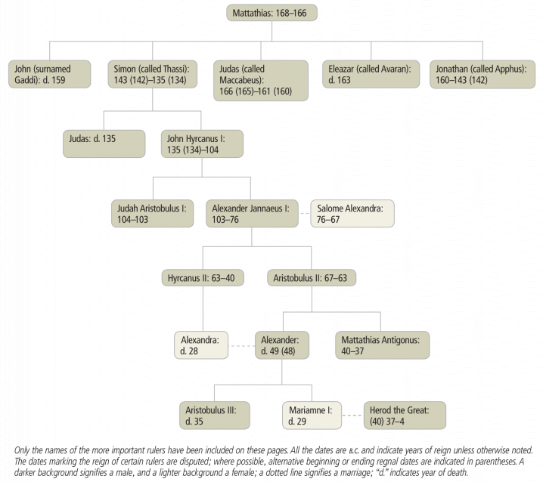
11:7–9 Ptolemy II in Egypt was succeeded by Berenice’s brother, Ptolemy III Euergetes I (246–221 b.c.), a branch from her roots. In retaliation for the death of his sister, Ptolemy III invaded the Seleucid kingdom and conquered its capital, Antioch (He shall come against the army and enter the fortress of the king of the north). He took the Syrian gods and other precious vessels of silver and gold and even returned to Egypt some of the sacred idols taken by the Persian monarch Cambyses in 524 b.c. when he had sacked the Egyptian temples. For this latter feat the Egyptians gave him the title “Euergetes” [Benefactor]. Afterward Ptolemy III made a peace treaty with Seleucus II Callinicus (246–226 b.c.) and he did refrain from attacking them so that he could work on expanding his kingdom in the Aegean area. Verse 9 says that Seleucus II shall come into the realm of the king of the south, but there is no record of such an invasion and he must have made a swift and hasty retreat (shall return to his own land).
11:10 After Seleucus II Callinicus’s death in 226 b.c. his sons (Seleucus III Ceraunus, 226–223; and Antiochus III the Great, 223–187) continued skirmishes with the Ptolemies. Seleucus III was murdered after a short reign, but his brother took the disorganized state and made it a strong nation. In 219–218 b.c. Antiochus III campaigned in Phoenicia and Palestine so that he made it as far as his fortress (in Raphia, southwest of Gaza).
11:11–12 Ptolemy IV Philopator (221–204 b.c., king of the south) responded quickly to Antiochus III’s advances and administered a severe defeat at Raphia in Palestine. Antiochus III’s losses were very high (Ptolemy IV cast down tens of thousands), yet Ptolemy IV’s victory was short-lived (he shall not prevail). From this point in the chapter the Ptolemies begin to weaken as the Seleucid kingdom becomes increasingly dominant.
11:13 After a period of about 15 years, Antiochus III (the Great, 223–187 b.c., the king of the north) invaded Phoenicia and Syria with a great army. Ptolemy IV had just died (203 b.c.), and Antiochus III intended to use the instability around the young king (Ptolemy V Epiphanes [203–180]) to his advantage. It worked, at least initially, and by 201 b.c. the fortress of Gaza had been recaptured, possibly with the help of Philip V of Macedonia.
11:14 There was indeed instability around the beginning of Ptolemy V Epiphanes’s reign (many shall rise against the king of the south). Even a large number of Jews were tired of the heavy taxation of the Tobiads (who naturally favored Egypt), and many Jews believed that rule by the Seleucids would be preferable. A rebellion by many Jews (the violent among your own people) attempted to overthrow Egyptian rule, but General Scopas of the Egyptian army, angered at their rebellion against the Ptolemaic nation, punished the leaders of Jerusalem and Judah.
11:15–16 Antiochus III the Great (the king of the north) fought against General Scopas and the forces of the south at the battle of Panium (near Paneas, which is NT Caesarea Philippi), a well-fortified city, in 198 b.c. (Polybius, Histories 16.18; 28.1). The Egyptian forces were soundly defeated and they fled to Sidon, where General Scopas finally surrendered. Antiochus took control of Phoenicia and Palestine (the glorious land—probably so named because of God’s plan and care for this land, cf. Dan. 8:9; Ezek. 20:6), and it remained under Syrian control until Pompey’s invasion in 63 b.c. established Roman rule.
11:17–19 After General Scopas’s surrender, Egypt was forced into an alliance with the Syrians. Antiochus III the Great even gave his daughter, Cleopatra (not the famous one from a later period, associated with Julius Caesar and Mark Antony), to Ptolemy V in marriage. Antiochus III hoped that her offspring would rule over Egypt to give him further power over Egypt, but Cleopatra supported Ptolemy V Epiphanes instead of her father (it shall not stand or be to his advantage). Verses 18–19 record Antiochus III’s initial successes in the region of the coastlands (a reference to Asia Minor and possibly also mainland Greece), but ultimately he was defeated by Roman and Greek troops. The Romans forced him to sign a treaty at Apanea in 188 b.c. and surrender territory, much of his military force, and 20 hostages (one was his son Antiochus IV Epiphanes). He was also forced to pay a large tribute to Rome. He returned home and was killed by an angry mob (he shall stumble and fall) while he was trying to pillage a temple of Zeus in Elymais to pay for the heavy tribute to Rome.
11:20 Antiochus III the Great’s son Seleucus IV Philopater (187–175 b.c.) succeeded him and sent a “tax collector” (or an exactor of tribute), Heliodorus, to collect the money necessary to pay Rome their yearly tribute of 1,000 talents. He even tried to plunder the temple in Jerusalem, but decided against it after being terrified by a dream (cf. 2 Macc. 3:7–40). Seleucus IV was not killed in anger (i.e., by an angry mob like his father), or in battle, but was poisoned by his own tax collector, Heliodorus.
11:21–23 In his place shall arise a contemptible person, Antiochus IV Epiphanes (reigned 175–164 b.c.), who is also the “little horn” of ch. 8 (8:9–12, 23–25). He took the name Antiochus “Epiphanes” (“Manifest One”; see note on 8:25), but others called him “Epimanes” (“madman”). Seleucus IV Philopater’s son, Demetrius I Soter, was the rightful heir to the throne, but because he was imprisoned in Rome, Antiochus IV Epiphanes took the throne, even though royal majesty had not been given to him. He paid off important people for supporting him, which is what the phrase to obtain the kingdom by flatteries refers to. Ptolemy VI Philometer (181–145 b.c.) of Egypt came against Antiochus IV but was defeated and held as a hostage. Later Ptolemy VI (the prince of the covenant) made an alliance (a covenant) with Antiochus IV to regain his throne because his brother (Ptolemy VIII Euergetes II Physcon) had taken it while he was imprisoned in Syria. This worked, and he received his throne back, but later he broke this covenant and joined with his brother Ptolemy VIII, to force Antiochus IV out of Pelusium, one of Egypt’s fortress cities.
11:24 Without warning, Antiochus IV Epiphanes retaliated and plundered some of the richest parts of Egypt’s territory (i.e., even Judea). He appeared to divide plunder among his soldiers (cf. Livy, Roman History 41.20; 1 Macc. 3:30; Polybius, Histories 26.1), but his grand plans against Egypt’s strongholds lasted only for a time (i.e., a time set by God).
11:25–27 These verses appear to refer to the events of Antiochus IV Epiphanes’s first battle with Egypt (cf. v. 22) and explain in more detail why Ptolemy VI Philometer was defeated. Ptolemy VI’s own trusted counselors (those who eat his food) encouraged him to go against Antiochus IV (his uncle), and he was defeated. Then the two kings, Antiochus IV and Ptolemy VI (now the former’s prisoner), made a covenant to regain control of Egypt from Ptolemy VI’s brother, Ptolemy VIII, but neither king intended to keep the covenant (they shall speak lies to each other)—merely intending to use each other for their own advantage. While their alliance had initial success capturing Memphis, it failed to capture all of Egypt, and Ptolemy VIII continued to rule in Alexandria. Later the two brothers, Ptolemy VI and Ptolemy VIII, joined forces and ruled together over all of Egypt.
11:28 Antiochus IV Epiphanes returned to his land after plundering Egypt in 169 b.c., and on his way home stopped in Palestine and found an insurrection going on (cf. 1 Macc. 1:16–28; 2 Macc. 5:1–11). He dealt ruthlessly with the Jews (his heart shall be set against the holy covenant), killing eighty thousand men, women, and children (2 Macc. 5:12–14) and plundering the temple (2 Macc. 5:15–21). The Jews were infuriated at the brutality of this ruler and began a full-fledged revolt (generally called the Maccabean Revolt; see map).
11:29–30 In 168 b.c. (i.e., the time appointed by God) Antiochus IV Epiphanes invaded Egypt again, but this time he met with a humiliating defeat. The Romans had joined forces with the Ptolemies, and Antiochus IV was no match for the Roman army and especially the ships of Kittim (“Kittim” is the ancient name for Cyprus, but it came to be used for the lands around the Mediterranean Sea in general, and in this case specifically the Romans). Several early historians (cf. Polybius, Histories 29.27; Livy, Roman History 45) tell the story of the defeat of Antiochus IV, stating that the Roman commander Gaius Popilius Laenas met Antiochus IV outside Alexandria and handed him a letter from the Roman senate telling him to leave Egypt or risk war with Rome. Next he drew a circle around Antiochus IV and told him to decide before he left the circle. Antiochus IV wisely chose to leave Egypt. In 167 b.c. he turned his anger toward Palestine (and be enraged and take action against the holy covenant) and sent his chief tax collector, Apollonius, to Jerusalem. Initially Apollonius appeared to come in peace, but on the Sabbath he began killing people and plundering the city (cf. 1 Macc. 1:30–32; 2 Macc. 5:25–26). He also rewarded those Jews who supported the Hellenistic policies, like the high priest Menelaus (he will pay attention to those who forsake the holy covenant).
11:31–32 Later in 167 b.c., Syrian forces came back to suppress the Jewish religious practices in earnest. They entered the temple (possibly called the temple and fortress because it was the religious strength of the people, or else Antiochus IV Epiphanes profaned the temple and a fortress also). They stopped the regular burnt offering, and on the fifteenth day of Chislev (December), 167 b.c. (1 Macc. 1:59), they set up an altar or idol devoted to Zeus (Jupiter) in the temple (the abomination that makes desolate; cf. Dan. 9:27; 12:11) and shortly afterward offered up sacrifices (likely swine) on the altar (1 Macc. 1:47; 2 Macc. 6:4–5). The Greek for this expression (bdelygma erēmōseōs, “abomination of desolation”) is applied to this action of Antiochus IV (1 Macc. 1:54) and is the background for Jesus’ prediction of “the abomination of desolation spoken of by the prophet Daniel” (see notes on Matt. 24:15; Mark 13:14). Antiochus IV’s flattery enticed some of the Jews to turn against the covenant (cf. 1 Macc. 2:18; 2 Macc. 7:24). But some faithful Jews (those who know their God) chose to stand strong and die rather than go against God’s laws (1 Macc. 1:62–63), and many did die. Some also began to organize a revolt (take action), probably referring to the priest Mattathias and his five sons who led the Maccabean Revolt and who in 164 b.c. rededicated the temple (1 Macc. 4:52).
11:31 See note on 8:10.
The Maccabean Kingdom
c. 167–63 b.c.
The Maccabean kingdom of Israel had its beginnings when the priest Mattathias and his family refused to obey the Seleucid rulers’ order to sacrifice to the pagan god Zeus at Modein. They led a revolt that initially controlled only the territory of Judea in the vicinity of Jerusalem. Over the next hundred years, however, the Maccabean rulers slowly added portions of territory to the kingdom until it resembled the borders of the territory allotted to the Israelite tribes by Joshua.
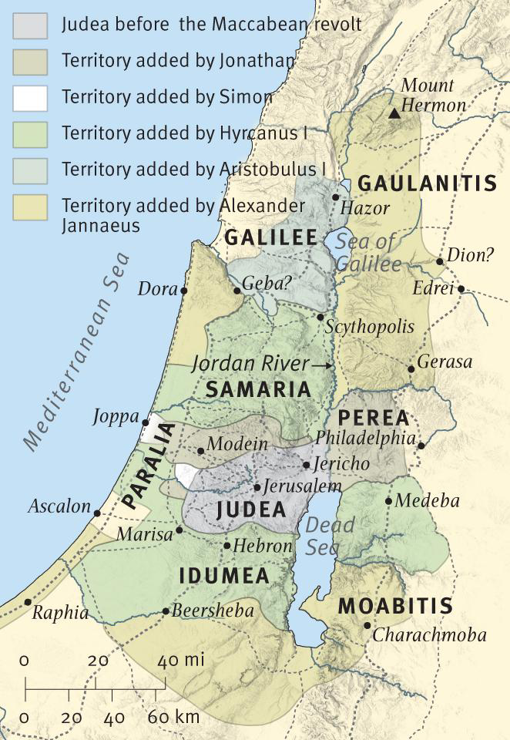
11:33–35 the wise among the people shall make many understand. This likely refers to those who truly fear God and who will encourage others to fight and even die rather than perform abominations before God. This refers primarily to the Maccabean Revolt. In that process many (tens of thousands) would die. In this time of persecution, the nation will receive a little help, which probably refers to the small forces that initially rebelled against the Syrians in Modein, 17 miles (27 km) northwest of Jerusalem, led by Mattathias and later his third son Judas Maccabeus (1 Macc. 2–4). The rest of Dan. 11:34 probably has in view the many who would join themselves to the Maccabean rebellion out of necessity to save their lives, though it may more specifically refer to the Hasidim who joined with the Maccabeans and killed those who were sympathetic to the Seleucids (cf. 1 Macc. 2:42–48). Some of the wise shall stumble likely describes true believers who would die in this persecution; through this persecution they would be refined, purified, and made white. Similarly, church history has shown that the Christian church has flourished under times of intense persecution, which may be what Dan. 11:35b is referring to (until the time of the end). But at least it refers to the end of Antiochus IV’s persecution, which ended with his death in 164 b.c. while he was on a campaign in Persia.
11:35 The refining process looks forward to God’s refining of the church (Rom. 5:3–5; Heb. 12:3–11; 1 Pet. 1:6–7).
11:36 Toward the conclusion of the prophecy, the vision seems to shift focus and address a situation that transcends the persecution under Antiochus IV, and thus the remainder of the chapter is often thought to deal with the “Antichrist” (taken by many as the figure in 2 Thess. 2:3–4; Rev. 13:5–8). Though Antiochus IV was powerful, he was able to do as he wills only up to a point, since the power of the Romans was far greater than his.
11:36 The king is either the man of lawlessness of 2 Thess. 2:3–4 or a foreshadowing of him.
11:37–38 Antiochus IV viewed himself as a god, as his nickname “Epiphanes” (“[god] manifest”) and coinage made clear (see note on 8:25). But it is doubtful that he fulfilled the prophecy, he shall magnify himself above all. He abandoned the gods of his fathers, including Apollo, and showed no regard for the one beloved by women, probably the god Adonis or Dionysius. Instead, he worshiped Zeus, a god who embodied military strength, but all these gods were still in the Greek pantheon and thus there is some question as to whether Antiochus IV abandoned “the gods of his fathers.” Instead this person will worship the god of fortresses (i.e., of military power and might) and will spend lavishly (gold and silver, with precious stones and costly gifts) to support this strength.
11:39 The passage probably speaks of a future king who will be a larger and more ultimate version of Antiochus IV Epiphanes, one who will truly “do as he wills,” will deal with the strongest fortresses, and will make his followers rulers over many. Many interpreters see here another prediction of the Antichrist, whom they connect to the “little horn” of ch. 7 and the ruler of 9:26 who is to come. The NT has been taken as referring to him in various ways (“the man of lawlessness,” 2 Thess. 2:3–12; “antichrist,” 1 John 2:18; “the beast,” Revelation 11–20).
11:40–41 At the time of the end there will be a major battle where armies will come from the north and the south to attack this powerful ruler in the land of Israel (the glorious land). Edom and Moab and the main part of the Ammonites will escape from his hand, possibly because of their connection with Israel or because they are out of his way.
11:44–45 One striking difference between Antiochus IV Epiphanes and the Antichrist lies in the events surrounding the king’s death, which do not fit what is known of the death of Antiochus IV. He met his end during a relatively minor campaign against Persia in 164 b.c., not between the sea and Jerusalem after a grand and successful assault on Egypt. When compared to the precision of fulfillment of the previous verses of ch. 11, these verses may be looking for a greater fulfillment that is yet to come at the time of the end. the glorious holy mountain. This is the Temple Mount in Jerusalem, which perhaps here should be connected to the fall of the Antichrist in the battle of Armageddon (cf. Rev. 16:13–16).

c. about, approximately

