Read Genesis 5:1-32
1. What did you learn from the sermon or Word Like Fire?

2. Read Gen. 3:15. Why do you think Moses places this genealogy, at this point, in the book of Genesis and how is it related to the promise of Gen. 3:15?

3. What does it mean that our children are made in our likeness and image and how is this part of God's blessing for us? (If you do not have children consider this from the standpoint of being made in your parent’s image)

4. Review the genealogy timeline below. How many generations Noah's grandfathers were still alive during His life? How could you be more intentional about passing on your knowledge of God to future generations?

5. What might've Moses intended to convey about Enoch's walking with God and then being taken so early? (See Heb. 11:5) How would you evaluate the closeness of your walk with God and how could it grow closer?

6. Challenge. What are some of the similarities between Noah and Christ's relief from the curse? What are some of the differences?

7. Reflection. Consider the ways in which Jesus offers relief in your life and take some time to praise and thank Him for that.

Prayer Focus: Let's pray that we would lead our families and friends to rest in the relief of Jesus Christ.

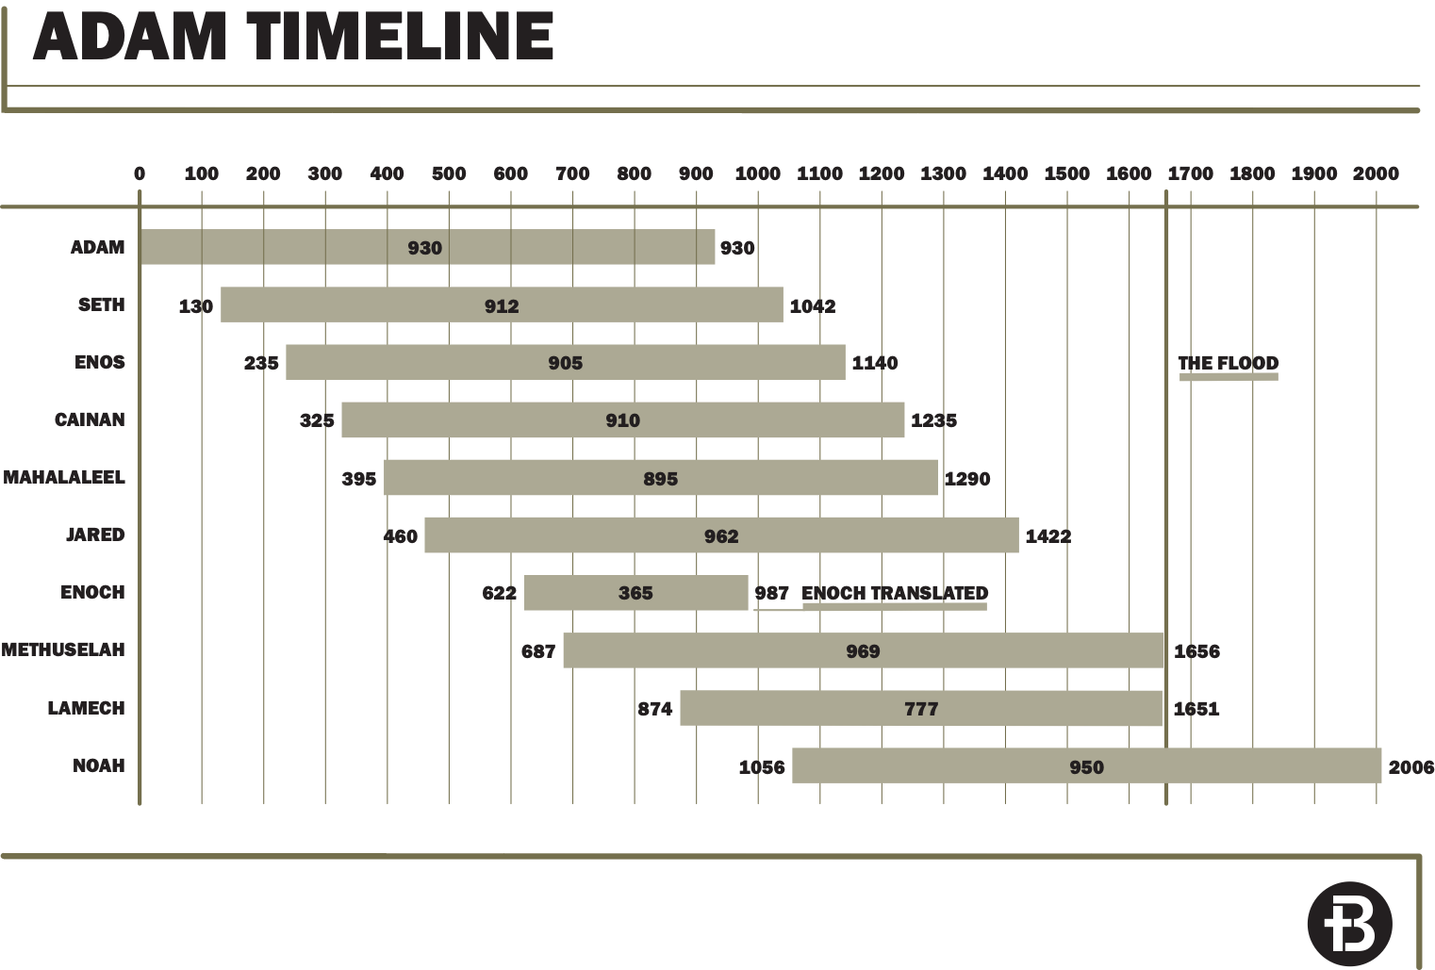

Consider Heb. 11:7, 1 Peter 3:20-21, Heb. 12:1-2 and other scriptures you find.

