Read Genesis 12:1-20

1. How did Sunday's sermon impact you or what did you learn in Word Like Fire?

2. Did God's promise of blessing and cursing have any conditions Abram would need to fulfill? Has God's unmerited grace ever come with conditions you had to maintain? Please explain.

3. Challenge. What is the ultimate spiritual fulfillment of God's promise to bless the whole world through Abram? (For help consider Gal. 3:7-9 & 16)

4. World View. What are the modern political ramifications of blessing or cursing Abram's offspring, especially when it comes to the promise of the land? How can we still bless Abram's offspring today, both on a political level as well as a spiritual one?

5. Crises, such as food a shortages, often provoke situations that are very fearful. What temptations to give into fear did Abram fail to overcome by faith? What past, present, or future fears are tempting you to take control over instead of trusting God?

6. What did God do to save Sarai and keep His promise to Abram? How have you experienced God restricting damage or consequences for unfaithful behavior in your life?

7. Reflection. Consider the ways in which God has been constantly and reliably faithful in your life even in the midst of your shocking failures.

Prayer Focus: Let's pray that we would trust God's promises in the midst of temptations to cave into fear.

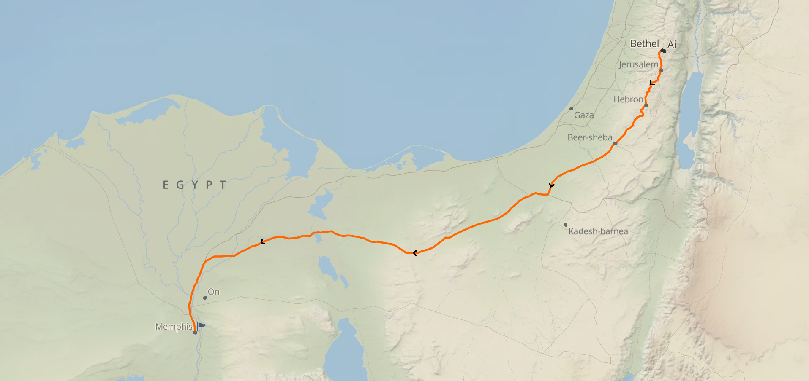

This type of question is one where the verses discussed should help to form significant areas of your world view.

