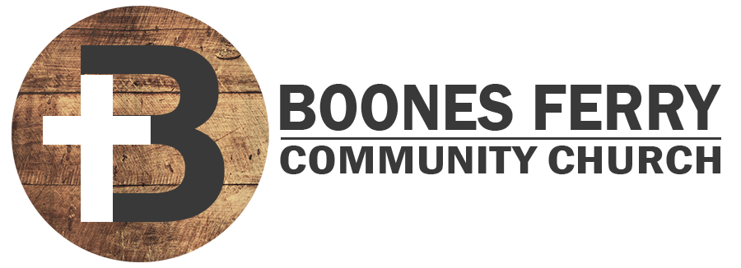
Read Genesis 14:1-24

1. How did Sunday's sermon impact you or what did you learn in Word Like Fire?

2. Consult the map and familiarize yourself with 4 kings coming from the north that are fighting the 5 kings near Sodom and Gomorrah. Try to explain what is actually happening in simplified terms.

3. Why does Abram get involved in the aftermath of this battle? Who in your life are you called to be loyal towards to the point of protecting them and opposing those who seek their harm?

4. Why would it have taken great faith for Abram to fight against Chedorlaomer? How does this story show us that God will work supernaturally to help us in our battles?

5. Read Heb 7:1-10. How does the author of Hebrews show that Melchizedek points us to Jesus Christ? How has our King and High Priest Jesus Christ blessed you even against your enemies?

6. Why do you think Abram did not want any financial ties to the King of Sodom. What principle could you draw from this in relationship to the people you partner with? (Read 2 Cor. 6:14 for help)

7. Reflection. What battles are you or someone you love facing that you need God to intervene and win for you?

Prayer Focus: Let's pray that we would trust God to fight for us and the ones we love against our enemies.

